
Trailer Estates Spectrum Bulk Contract
New equipment and services are available in the Trailer Estates bulk contract with Spectrum. A new recording service called Spectrum Cloud DVR is available and a new streaming video device named Xumo Streambox is an available equipment option. Also Spectrum is including streaming video services in the plan as well. Streaming video services such as Peacock, Paramount +, Disney +, Hulu, HBO/MAX, ESPN, AMC+, are also included and the list keeps growing. So if you already have a paid subscription with one these services you can cancel it and sign up through your Spectrum account and receive these services with no monthly fee.
Let’s review what is included and what choices you have and how the different services and equipment compare. Then call Spectrum to have your TV service and Internet service installed and activated if you have not already done so.
Before we begin it’s helpful to know the difference between a device and an app. When we say device we are referring to a piece of equipment that can connect to the Internet and play video. Example: Smart TV, Smart phone, tablet, streaming video device, etc. App is short for application. App is a software program that you install on a device.
OK let’s begin
The TE Spectrum bulk account includes the Spectrum TV Select package which has over 155 channels in the channel line up. To view the programs on your TV set connect a cable box, or use a device with the SpectrumTV app installed on it. With our bulk contract you get two pieces of TV equipment. Your choices are two cable boxes, or two Xumo Stream boxes, or you can select one of each. A cable box and a Xumo Stream box.
NOTE: The monthly rental fee for an additional cable box is $18.00. The monthly rental fee for an additional Xumo Stream box is $5 with option to own the device after 14 months.
The TE Spectrum bulk account also includes a choice of DVR recorder service. Choice #1) DVR recorder service on one cable box. or Choice #2) Cloud DVR service which allows you to view your recordings on any device that the SpectrumTV app is installed on.
NOTE: You cannot subscribe and have both recorder services on the same account.
The TE Spectrum bulk account includes Internet service. We get the 600 MPS Internet service. Spectrum supplys us with a modem and WiFi 6 router to connect to the Internet to create a secure WiFi network in our TE home.
Let’s discuss the different TV equipment Spectrum supplies.
CABLE BOX
Connect a cable box to your TV at your Spectrum service address you can view your Spectrum TV channel lineup. Press the the Guide button to see a list of 155 channels available. TE community channels, CH 732 and CH 733, only come in through a TV hooked up to a cable box in your TE home.
XUMO STREAM BOX
The Xumo Stream box is a streaming video device and it connects your TV to the Internet. So if your TV is not a Smart TV it will be once you connect it to a streaming video device. The Xumo Stream Box has many apps already installed on it one of which is the SpectrumTV app. You will be viewing your Spectrum TV channel lineup through this app. Also it has many of the different streaming video apps that Spectrum is offering already installed on it. CH 732 and 733 are not available on any streaming video devices through any apps.
NOTE: The TE trustee board meetings and workshops are broadcast on the parks YouTube station and the YouTube app is preloaded on the Xumo Streaming Box and available on many other streaming video devices.
HOW TO GET AND USE THE SPECTRUM TV APP
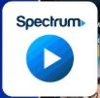
The SpectrumTV app is available to install on your device in the App Store and Google Play. To use the SpectrumTV app on any device you must first register your Spectrum account and create a Spectrum user ID and password. If you already have other streaming video devices of your own and install the SpectrumTV app on them you can watch the Spectrum TV channels included in the bulk contract on these devices anywhere where as long as you have an Internet connection at the location.
Also if you chose the Xumo Streaming Box as an equipment choice you can take your Xumo Streaming Box with you when travel and connect it into a HDMI input in a TV somewhere else.
Xumo Stream Box operates on a "locked" system with no app store, meaning you cannot download or sideload apps that are not pre-installed or pre-approved by Xumo/Spectrum. Users are limited to a curated selection of over 250 apps and cannot uninstall default applications.

However it is a piece of equipment provided in our TE bulk contract so if you don’t want to purchase a new TV or streaming video device which has the SpectrumTV app and the other streaming apps you desire included in our contract it’s a good option.

Let’s discuss recorder services:
Cable box with DVR built in allows you to schedule multiple recordings of programs when they are broadcast. Once they are recorded you can only watch them on the TV hooked up to that specific cable box at the Spectrum service address only. When you rewind, pause or fast forward a time line at the bottom of the screen will display video frames so you can see what point in the program you have reached and see when to resume play.
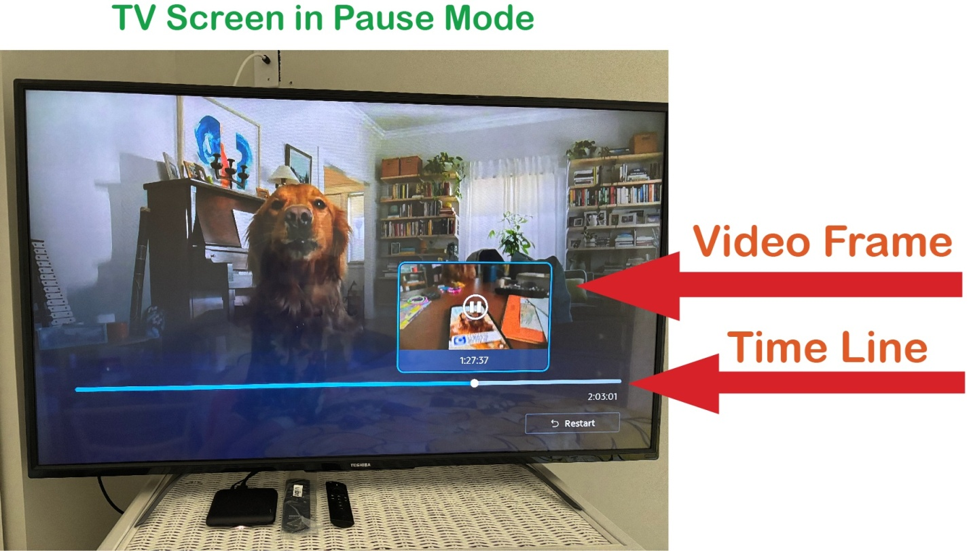
The video frames make it easy to see the point in the programs time line you have reached to know when to resume play.
The time line displays the point of time in the program you have reached, but it is difficult to read the small, white font. Especially on a backdrop of a paused video frame that may have a light background.
Cloud DVR Service allows you to schedule multiple recordings of programs and you can watch them on any TV or device the SpectrumTV app is installed on any where you can connect to the Internet. Select My Library in the app menu to view your recordings. You can pause, rewind and fast forward through recording however video frames do not display on the time line using the app on all devices. The SpectrumTV app installed on a Roku device will display the thumbnails when viewing LIVE TV mode but not display them when viewing a recorded show in Library. Contrary to using the SpectrumTV app installed on a Xumo device not supplied by Spectrum. I purchased a Pioneer Smart TV with Xumo built in it in 2024 and I can not pause LIVE TV but it does display video thumbnails viewing a recorded show from the Library. The only device the time line and video thumbnails display in both modes ( LIVE TV and recorded Library) is on a Xumo Stream box supplied by Spectrum.
Here are some other differences with the two recording service options:
Cable box with DVR This DVR service allows you to pause, rewind and fast forward in LIVE TV mode. Keep in mind you can only rewind back to when you first tuned into the station up to 90 minutes back.
Cloud DVR Service Pause, rewind and fast forward in LIVE TV mode is only available on a Xumo device supplied by Spectrum and it can only rewind back to when you first tuned into the station up to 30 minutes back.
Cable box with DVR You can record a show already in progress. Select it in the guide and hit record button.
Cloud DVR Service Does not allow you to record a program that is already in progress. You must schedule your recordings in advance.
Cable box with DVR CH 732 and CH 733 are available and you can pause if you need more time to read the bulletins.
Cloud DVR Service CH 732 and CH 733 are not available.
Cable box with DVR The buttons on the Spectrum remote control are easier to follow since the design has been around for decades, and it responds to touch promptly. Also Spectrum provides remote controls for users with disability.
Cloud DVR Service The buttons on a Xumo remote control are very sensitive and there seems to be a delay in response time. Also sometimes it’s tricky to rewind and fast forward. The back button become very useful when screens pop up you didn’t request.
Let’s discuss the options of having one cable box and one Xumo Stream box. Maintaining and repairing the infrastructure that delivers service to our homes is always ongoing. If the Internet is down for maintenance and repair usually the cable service is up and working and vice versa. So it’s nice to have at least one service working when maintainance is being performed on the other service.

STREAMING VIDEO SUBSCRIPTIONS
In order to view the different streaming video services Spectrum offers you must log into to your Spectrum account online and register a user ID and password for each streaming service you want to use. Once you have registered you then have to sign in using these credentials on every different device you would like to view these streaming services on.
If you have trouble or need assistance with a streaming service call the app provider directly not Spectrum. The streaming services are offered as part of the Spectrum contract but Spectrum does not provide help with registration or technical assistance. Spectrum will refer you directly to the streaming service provider. Here are some phone numbers I collected:

Peacock 833-580-0577
Disney Plus 888-905-7888
Hulu 888-265-6650
ESPN 800-727-1800
Paramount Plus 888-274-5343
AMC contact through website
HBO MAX 855-442-6629
Tennis Channel
FOX ONE
ViX
I hope this article helped you learn how make the most out of your Spectrum services.
Karen Harker
Training Committee Chair

